# Roderick Fisher CS 340 README Template

*.*

## About the Project/Project Title

*The purpose of this project was to create a functioning web-based dashboard widget that can be used by the company Grazioso Salvare for the purpose of matching dogs that could be of use to them from the Austin Animal Shelters database. This project utilizes CRUD, (create, read, update, delete) to interact with MongoDB. We are utilizing Mongo to interact with the animal data. We have also used Python as a middleware that consist of a class that holds our CRUD arguments. For visitation purposes we are using a combination of* Plotly, Dash, and Leaflet.

## Getting Started

Open Apporto

Establish connection and authentication through MongoDB using the Linux Terminal

Run /usr/local/bin/mongod_ctl start

Be sure that the python module is on your local drive

Open Jupyter Notebooks

Open IPYNB file

Enter username and password

Run the opened IPYNB file

## Installation

Please be sure to have the following tools installed

Python 3.6

Pymongo 4.2

MongoDB 4.2

Plotly

Dash Leaflet

## Usage

*This code can be used to search the Austin Animal Shelter’s animal database. You also have the options to select different options such as rescue and water to retrieve dogs that fit the criteria of each. This code also allows you to filter animal by type, ID, ages, and more.*

### Code Example

Import statements for CRUD Module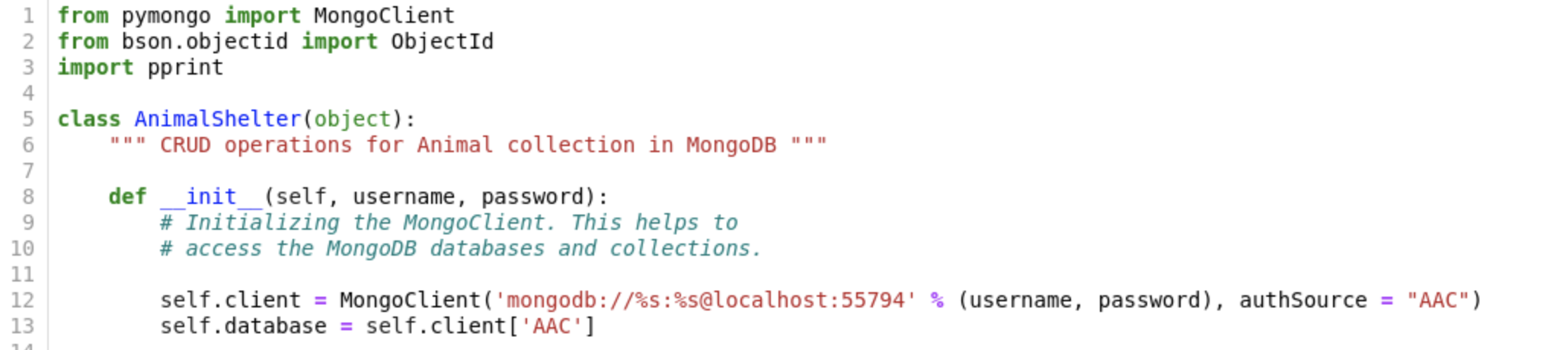

Create, Read, Update, and Delete of CRUD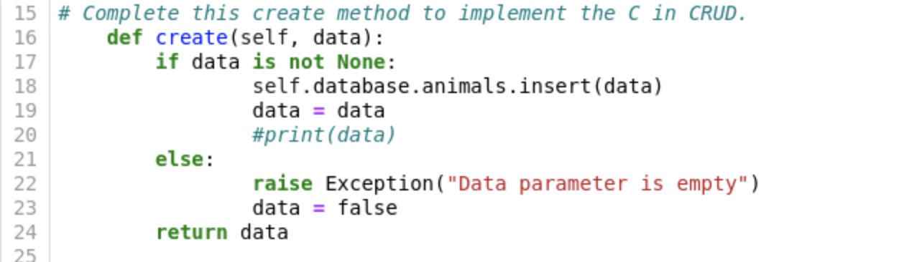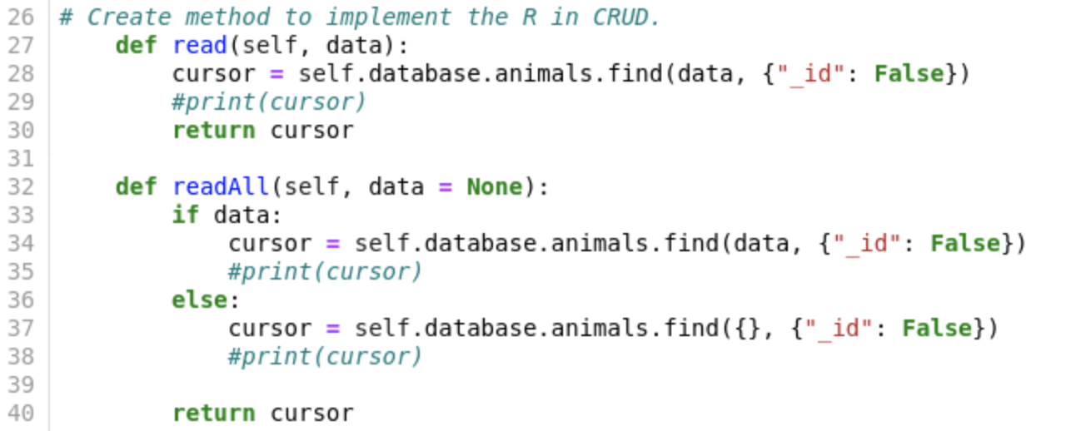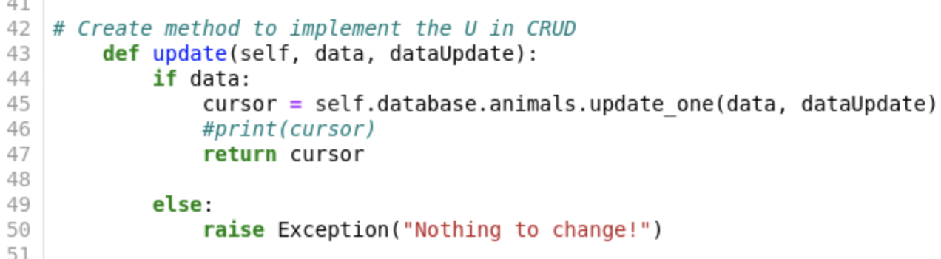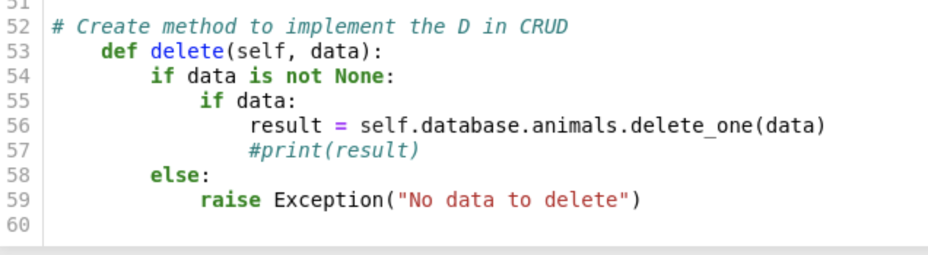

Jupyter Notebook Import statements 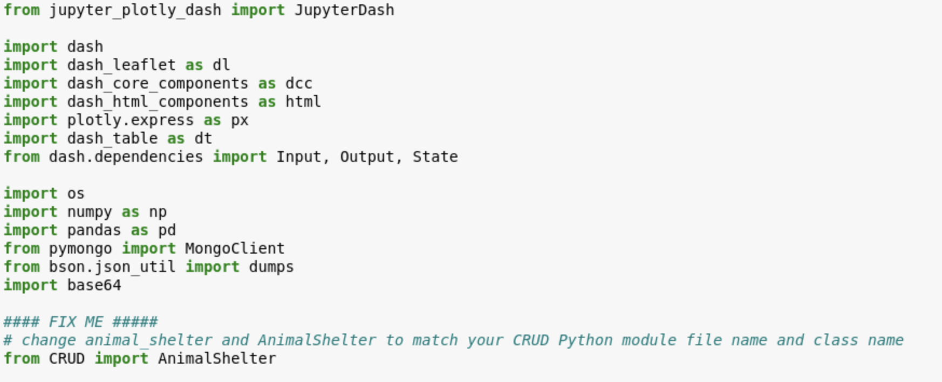

Connect username and password to the CRUD.py file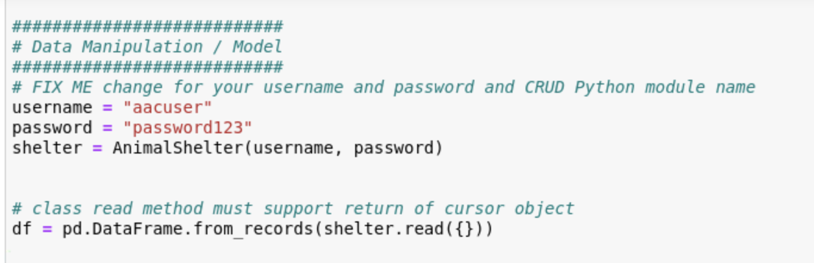

HTML div holdings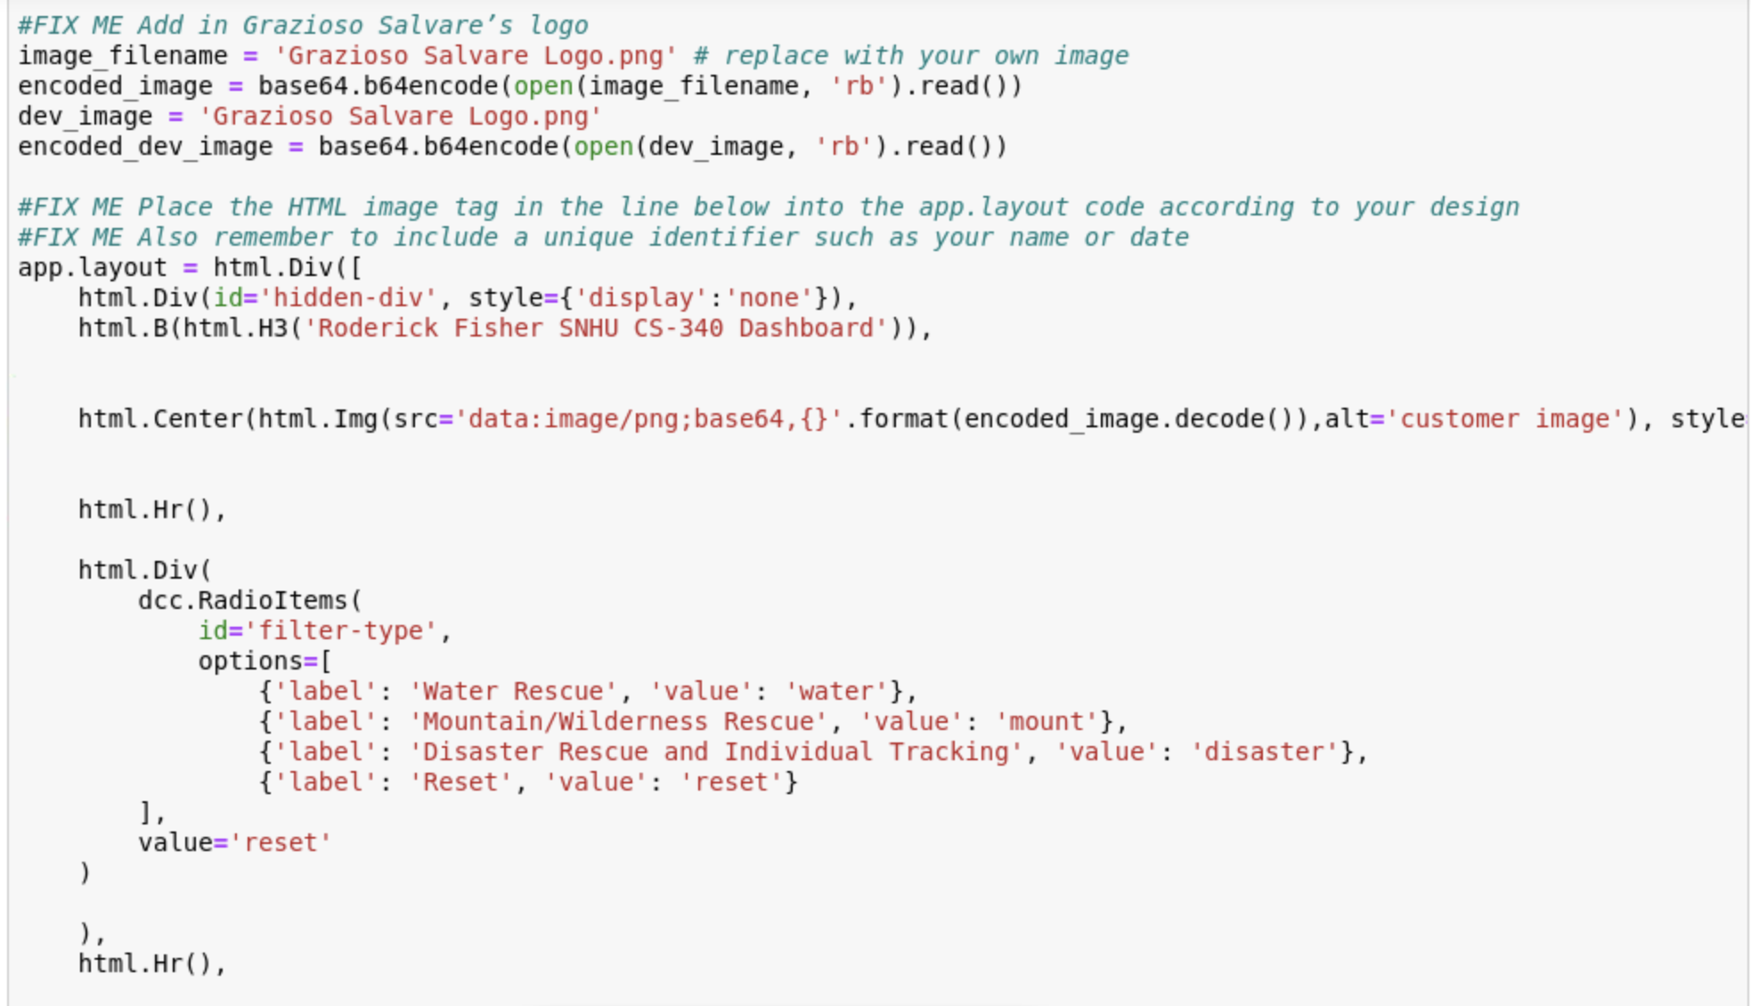

### Screenshot 2023-02-25 at 12.25.15 PM.png

### ScreenshotsScreenshot 2023-02-23 at 11.59.48 AM.png

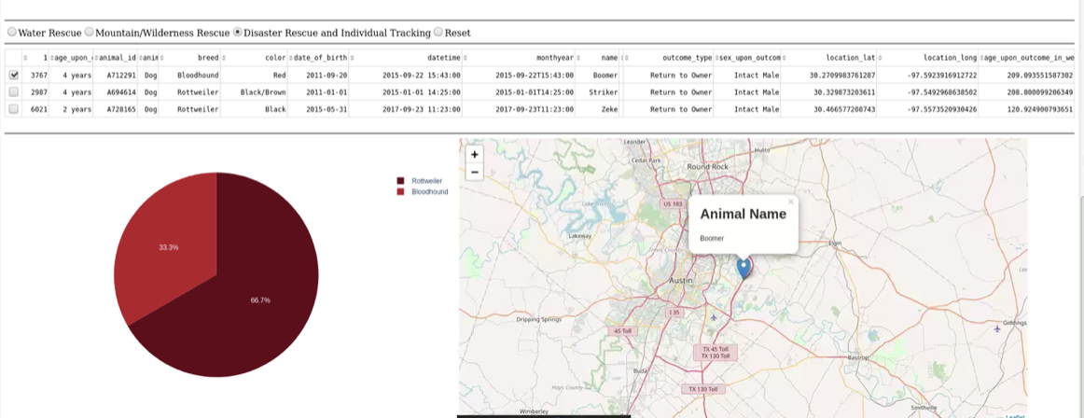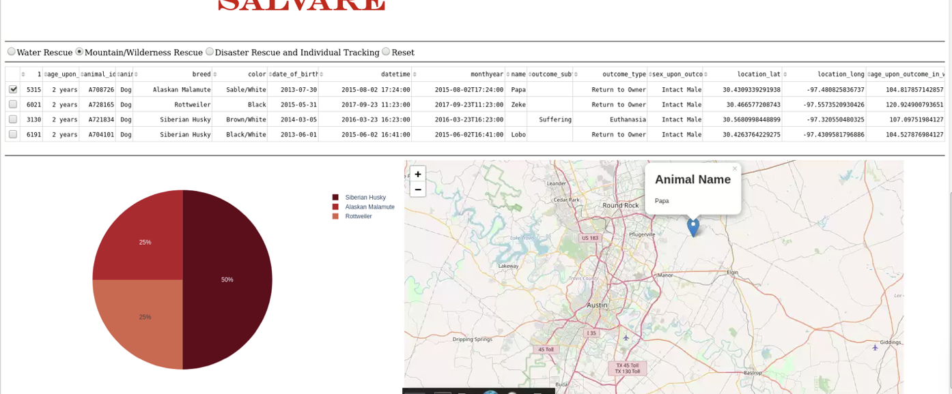

## Challenges

The challenge that I had was trying to filter the dogs that were needed for rescue. Some of the dogs are not listed with their full breed type so you have to implement a way to match patterns in word to find the needed breed types. I overcame this by including a way to find pattern of letters in my filter.

## Contact

Roderick Fisher